Maximize Your Visit with Disney MaxPass
Purchase Tickets with Disney MaxPass
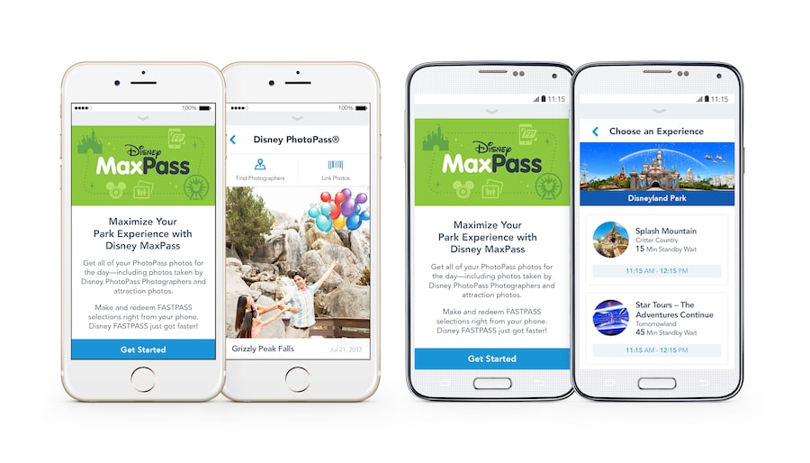
Do more than ever before when you purchase Disney MaxPass:
- Save time in line at popular attractions by making Disney FASTPASS selections on your mobile device* using the Disneyland app while you’re in the parks. Guests with Park Hopper Tickets can even make selections for attractions in our other theme park.
- Capture all of your memories with unlimited Disney PhotoPass photo downloads** for a day. Download and share photos from select dining locations, attractions, Character Greetings, Disney PhotoPass Photographers and Magic Shots.
Disney MaxPass is available for the low introductory price of only $10 per day, per ticket—so you can experience more of the park with the people you love!

How to Purchase and Use Disney MaxPass If You Have Tickets
- Download the Disneyland app.
- Enter the park you wish to visit using your tickets.
- Open the Disneyland app.
- Tap the circular character icon at the bottom of the screen.
- Sign in with your Disney account.
- Tap “Get FASTPASS with Disney MaxPass”.
- Select all Guests in your party who wish to use the Disney MaxPass feature—if someone is not listed, link their ticket or pass.
- Purchase the Disney MaxPass feature for any Guests who do not already have it.
- Make your FASTPASS selections and enjoy your Disney PhotoPass downloads.

How to Purchase and Use Disney MaxPass If You Don’t Yet Have Tickets
- Purchase tickets on disneyland.com with the Disney MaxPass feature for your party.
- Download the Disneyland app.
- Enter the park you wish to visit using the tickets.
- Open the Disneyland app.
- Sign in with the same Disney account you used to purchase tickets.
- Tap the circular character icon at the bottom of the screen.
- Tap “Get FASTPASS with Disney MaxPass”.
- Select all Guests in your party who wish to use the Disney MaxPass feature—if someone is not listed, link their ticket or pass.
- Purchase the Disney MaxPass feature for any Guests who do not already have it.
- Make your FASTPASS selections and enjoy your Disney PhotoPass downloads.

How to Link Disney PhotoPass Photos
It’s fast and easy to link photos to your Disney account:
- Ask Disney PhotoPass Photographers to either scan your Disney PhotoPass card or the code on your phone. Be sure to also link your Disney PhotoPass card to your Disney account.
- Enter the ID code for attraction photos in the Disneyland app. You’ll find the 8-character code on the photo monitor near where you exit the attraction. Ask a Cast Member for help if you cannot locate your photo.

Disney MaxPass for Annual Passholders
Guests who have a valid Disneyland Annual Passport may purchase the Disney MaxPass feature as an annual add-on for $75 at a Disneyland Resort Ticket Booth or as a daily add-on for $10 through the Disneyland app. The Disney MaxPass feature is an included benefit with the Disney Signature Plus Passport and the Disney Premier Passport.
The cost of the annual Disney MaxPass feature cannot be prorated for Annual Passports expiring in less than a year, and the feature expires when your Annual Passport expires.

Help
Have more questions or need additional details? Visit the FASTPASS and Disney PhotoPass Guest Services pages. You can also check out the Frequently Asked Questions about Disney PhotoPass.
* Guests are strongly advised to check the day’s FASTPASS availability and other park details before purchasing Disney MaxPass or using a park ticket with Disney MaxPass. FASTPASS selections for popular attractions may not be available at the time of Disney MaxPass purchase or use as FASTPASS selections are limited and availability is not guaranteed. FASTPASS selections may be made only while you are in the parks.

An experience that does not have FASTPASS availability at a physical FASTPASS service machine will not be available using the Disney MaxPass feature. FASTPASS selections for entertainment may not be available, and the FASTPASS selections available through Disney MaxPass are subject to change without notice.
The Disney MaxPass feature is nonrefundable, nontransferable and may not be redeemed for cash. No credit will be given towards any ticket upgrade for the amount of the Disney MaxPass feature purchased through the Disneyland app after park entry. If a ticket with Disney MaxPass is upgraded to a ticket without the Disney MaxPass feature, you will no longer be able to make FASTPASS selections from your phone—please plan your upgrade accordingly.
The Disney MaxPass feature will expire at the end of the day or when the Passport it is associated with expires, as applicable. Price, terms and entitlements are subject to change or cancellation without notice. Other restrictions may apply.
** Disney PhotoPass service is subject to the Disney PhotoPass Terms and Conditions. Online registration required. Disney PhotoPass photos captured during the day your Disney MaxPass is used or during the validity dates of your Passport, as applicable, must be linked to your Disney account and may be downloaded pursuant to the expiration policy. Not responsible for missing, lost or damaged photos. Downloads are restricted to personal use by Disney account holder only and may not be used for a commercial purpose. Subject to restrictions and change without notice.
Message, data and roaming rates may apply for the Disneyland app. Availability subject to handset limitations and features may vary by handset or service provider. Coverage and app stores not available everywhere. If you’re under 18, get your parents’ permission first.

